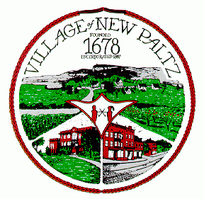
Village of New Paltz Village of New Paltz Village Hall
25 Plattekill Avenue
New Paltz, NY 12561
Date:
PUBLIC HEARING NOTICE

Please take notice that the Village of New Paltz will hold a Public Hearing on the following application (to review all submitted materials, please contact the Building Department, 8a.m.-4p.m., M-F, 255-3055):

Date Posted : July _____, 2017

Applicant: Dimitri Viglis

For: Second Floor - Changing from Restaurant to Apartment and Office Space

Location: 51 Main Street

Tax Map Number: 86.143-1-9.200

Date and Time: August 8, 2017 at 7:00 pm

Place: Village of New Paltz Village Hall

The Zoning Board of Appeals will hear all persons in support of such matter or any objections thereto during the public hearing at 25 Plattekill Avenue in order of appearance on the agenda. Comments submitted in writing must be received before 12 noon on the date of the above hearing and be addressed to the Planning and Zoning Secretary at the address listed above.

*All reasonable accommodations will be made for persons with disabilities. In such a case, please notify the Planning Board Secretary in advance so that arrangements can be made.
160210 Public Hearing Notice.docx

