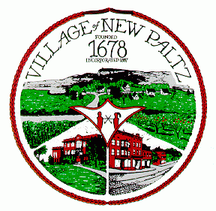
The Design Review Board & Historic Preservation Commission
of the Village of New Paltz
25 Plattekill Avenue - New Paltz, New York 12561
Thomas G. Olsen, Chair
Stephen Cook – Kamilla Nagy, Deputy Chair – Shane Reidy
William Wheeler-Murray, Village Board Liaison - Valerie McAllister, Secretary

(for publication on December 7 and December 14 in “Briefly Noted”)

Notice of Special Meeting

The Design Review Board & Historic Preservation Commission of the Village of New Paltz will hold a special meeting on Monday, December 19, 2022 at 7 p.m. to consider an application for certificate of appropriateness from Jeremy Robinson-Leon / Moonrise New Paltz LLC to renovate the façade at 87 Main Street in the Village of New Paltz. The special meeting, which will include a public hearing, will be held at Village Hall, 25 Plattekill Avenue, in the first-floor meeting room formerly used by the New Paltz Fire Department. Other business may also be addressed.
Interested parties may join the meeting in person or may participate via Zoom using the link posted on the Village of New Paltz’s home page (https://www.villageofnewpaltz.org). The live-streamed meeting will also be viewable on the Village’s YouTube channel, where a recording will subsequently be made available.
For more information, please contact the Commission secretary at hpc@villageofnewpaltz.org, or call the Village of New Paltz Building Department at 255-3055.

Submitted via e-mail 12/4/22

